****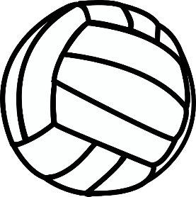

**Rossford Junior High**

**Volleyball**

**2022**

# ***All 7th grade matches begin at 4:15 unless otherwise noted***

Scrimmage

Tuesday August 16 @ Gateway

(7th 4:00 & 8th 5:00 pm)

Picture Day

Thursday August 18 Picture Day

Games

Saturday August 20 **Tri-match 10:00 am**

**Fassett/Ottawa Hills**

Monday August 22 at Woodmore

Wednesday August 24 **LAKE (5:00 pm)**

Monday August 29 @ Genoa

Wednesday August 31 **EASTWOOD**

Tuesday September 6 @ Fostoria

Wednesday September 7 **OTSEGO**

Monday September 12 at Elmwood

Wednesday September 14 **WOODMORE**

Monday September 19 @ Lake (4:30 pm)

Wednesday September 21 **GENOA**

Monday September 26 @ Eastwood

Wednesday September 28 **FOSTORIA**

Monday October 3 at Otsego

Wednesday October 5 **ELMWOOD**

NBC Championship Tournaments

Saturday October 8 7th @ Woodmore

Saturday October 8 8th @ Elmwood

Wednesday October 12 7th&8th finals @ Elmwood

**ROSTERS**

7th grade

Emily Myer – Coach

3 – Cece Weaks

4 – Celina Gomez

7 – Natalie Weaks

8 – Gracie Pierce

11 – Addison Bachmayer

15 – Norah Demory

17 – Caitlyn Extine

24 – Keaghan Mahaffey

29 – Makayla Tidwell

30 – Lillian Burtscher

8th grade

Megan Wood - Coach

6 – Cali Adams

12 – Camryn Almester

13 – Amelia Castilleja

14 – Makenzi Moncrief

18 – Gabby Long

20 – Chloe Nevins

21 – Nicole Grix

23 – Aubrie Buck